Software Requirement Specifications
Online Shopping System



Submitted by
Muhammad Adnan (S25BINFT7M04008)
Submitted to
Prof. Ali Nawaz Shah

Department of Information Technology
Faculty of Computing
The Islamia University of Bahawalpur

Meeting Details
Sr No | Details | Date | Supervisor Signature

Summary
Shopping for clothes online often feels like a guessing game, leading to the "return culture" that frustrates both customers and brands. This project introduces a streamlined e-commerce platform designed to replace measurement charts with intuition. The heart of the system is "The 15-Second Fit Quiz," a feature that shifts the focus from raw numbers to body geometry and personal style.
1. The Vision & Foundation
The primary purpose of this system is to act as a definitive roadmap for a platform where "Personalized" isn't just a buzzword, but a functional reality. By integrating body-shape-aware technology, the scope extends beyond a simple cart and checkout; it creates a curated environment where every item a user sees is filtered through the lens of their specific silhouette.
From a product perspective, the system is a complete, standalone ecosystem. It manages everything from secure payments and real-time inventory to a sophisticated recommendation engine that translates quiz answers into specific product suggestions.
2. User-Centric Design
The platform is built for three distinct groups:
- The Practical Shopper: People who value their time and want to avoid the hassle of shipping back ill-fitting clothes.
- The Style Enthusiast: Users who want to discover how different cuts—like oversized or tailored—look on their specific frame.
- The Administrator: Staff who use data-driven insights to see which body shapes are trending and adjust inventory accordingly.
While many competitors use complex sizing tools, our Literature Review showed a gap in the market for speed. By using a heuristic-based approach rather than requiring a tape measure, we prioritize user engagement without sacrificing accuracy.
3. Technical & Functional Excellence
Built on a modern stack featuring React/Flutter for a smooth interface and Node.js/Python for high-speed logic, the system is designed for performance.
- Core Functionality: The 15-Second Fit Quiz uses a visual, 5-question format to identify shapes (like the Inverted Triangle or Pear). Immediately after, the Personalized Storefront updates to show "Best Fit" badges on recommended items.
- Security & Speed: We’ve set high benchmarks for Non-Functional Requirements, ensuring that all body data is encrypted with AES-256 and that the personalized filtering happens in under 2 seconds to keep the shopping flow seamless.
4. The Experience (Use Case)
Imagine a user logging in and, within four clicks, seeing a storefront tailored specifically to them. By selecting visual icons that represent their body shape, the system instantly processes their profile. The result is a shopping journey where the user no longer asks "Will this fit me?" but instead "Which of these great fits do I want today?"

Table of Contents

1. Introduction 6

1.1. Purpose 6
1.2. Scope 6
1.3. Product Perspective 7
1.4. User Characteristics 7
1.5. Similar apps and systems/Literature Review 8
1.6. Proposed Technologies 8

2. Requirements 9
2.1. Function Requirements 9
2.1.1. Sign Up 10
2.2. Non-Functional Requirements 11

3. Use Cases and Flow of Processes 11
3.1. Use Case 1 12

4. References 13

1. Introduction

1.1. Purpose
The purpose of this SRS document is to provide a detailed description of the functional and non-functional requirements for the Online Shopping System – a web-based e-commerce platform specialized in clothing and fashion items. This document serves as a blueprint for developers, testers, and stakeholders to understand the system's objectives, features, constraints, and expected behavior. It ensures that the final product meets user needs for convenient, secure, and enjoyable online clothing shopping.

1.2. Scope
The Online Shopping System will allow users to browse, search, filter, and purchase clothes online. Key features include user registration/login, product catalog with categories (Men, Women, Kids), size/color filters, shopping cart, wishlist, secure checkout, order tracking, and an admin panel for managing products, orders, and users.

In Scope:

- User authentication and profile management
- Product browsing, search, and filtering
- Shopping cart and wishlist functionality
- Payment integration (simulated or real gateway)
- Order placement and tracking
- Basic admin dashboard
- Responsive web design for desktop and mobile

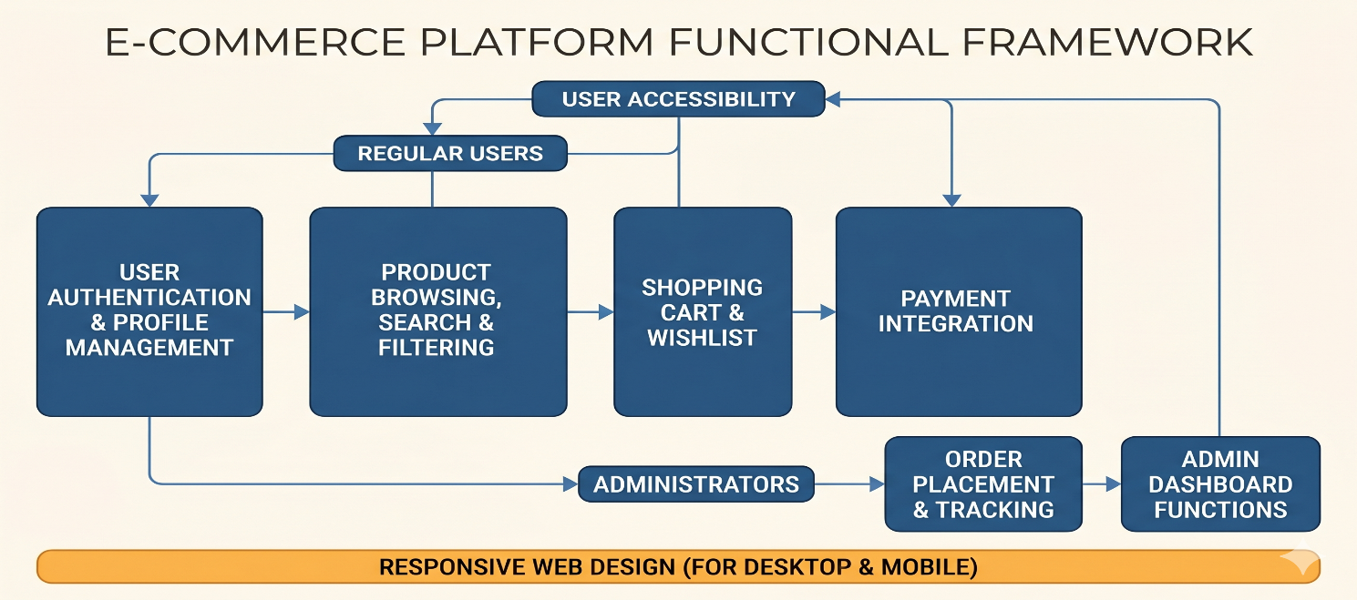

Out of Scope:

- Mobile native apps (iOS/Android)
- Advanced AI-based virtual try-on
- Multi-vendor marketplace (single store model)
- International shipping and multi-currency (focus on Pakistan/region initially)
- Physical inventory management hardware integration

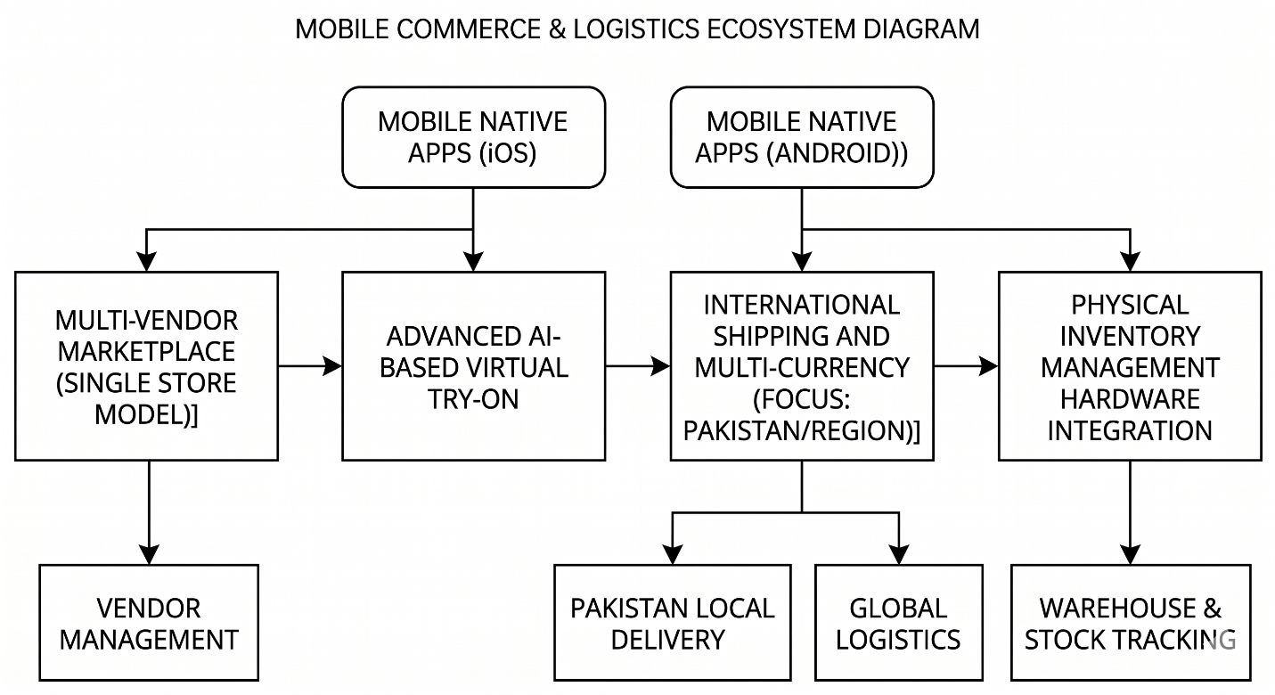

1.3. Product Perspective
This system is a standalone web application designed to provide a modern, user-friendly online shopping experience focused on clothing. It aims to solve problems like limited physical store access, time-consuming shopping, and lack of variety by offering a wide range of clothes with easy navigation, personalized recommendations, and secure transactions. It will be similar to existing fashion e-commerce platforms but tailored for simplicity and performance.

1.4. User Characteristics
The system targets the following users:

- Customers: General public aged 15–45, tech-savvy or semi-tech-savvy, interested in fashion. They expect fast loading, intuitive UI, mobile responsiveness, and secure payments.
- Registered Users: Frequent shoppers who maintain profiles, wishlists, and order history.
- Administrators: Store owners or managers who add/edit products, manage inventory, view orders, and generate reports. They require administrative privileges and analytical views.
- Guests: Users who can browse without registration but must sign up/login for checkout.

- Users are expected to have basic internet and web browsing knowledge.

1.5. Similar Apps and Systems / Literature Review
Several successful platforms offer similar functionality:

- SHEIN: Known for fast fashion, vast affordable clothing catalog, strong filtering (size, color, style), and personalized recommendations. Strengths: Trendy items, low prices; Weaknesses: Quality variability and longer shipping.
- ASOS: Focuses on trendy and inclusive fashion with excellent search, filters, and user reviews. Strong in UI/UX and fast checkout.
- Myntra (popular in South Asia): Multi-brand fashion portal with robust filters, size guides, and easy returns. Good for regional markets like Pakistan/India.
- Daraz (South Asia): General e-commerce with strong clothing section, cash-on-delivery support, and order tracking.

Literature and existing SRS documents for online clothing/fashion stores emphasize the need for secure authentication, efficient product search/filtering, responsive design, reliable payment processing, and strong non-functional aspects like performance and security. Common challenges include cart abandonment, mobile optimization, and building trust through reviews and returns policy.

1.6. Proposed Technologies

Frontend:

- React.js with Next.js (for SSR, better SEO, and performance)
- Tailwind CSS for responsive and modern UI
- State management: Redux or Context API

Backend:

- Node.js with Express.js
- RESTful APIs (or GraphQL if needed)

Database:

- MongoDB (NoSQL for flexible product attributes like sizes/colors) or PostgreSQL

Other Tools:

- Authentication: JWT + bcrypt (or NextAuth)
- Payment Integration: Stripe / PayPal / JazzCash / EasyPaisa (for Pakistan)
- Image Storage: Cloudinary or AWS S3
- Hosting: Vercel (frontend) + Render/Heroku/AWS (backend)
- Additional: Redis for caching, Docker for containerization

2. Requirements

2.1. Functional Requirements
The system shall support the following major modules:

User Management

- Users can register using email/phone and password.
- Users can login/logout and reset password.
- Users can view and update profile (name, address, phone, etc.).

Product Catalog

- Browse products by categories (Men, Women, Kids, Accessories).
- Advanced search with filters: price, size, color, brand, material, style.
- Product detail page with multiple images, description, size guide, reviews, and "Add to Cart"/"Wishlist" buttons.
- Recommended products section.

Shopping Features

- Add/remove items from shopping cart.
- Add/remove from wishlist.
- Apply coupons/discounts (if implemented).
- View cart summary with total calculation.

Checkout & Orders

- Secure checkout process with shipping address selection.
- Multiple payment options (Card, Cash on Delivery, Digital wallets).
- Order confirmation and email notification.
- Users can track order status (Pending, Shipped, Delivered, Cancelled).

Admin Panel
- Admin can add, edit, delete products (with images, variants: size/color).
- Manage categories and inventory.
- View and update order status.
- View user list and basic analytics (sales, popular products).

Additional Features

- Product reviews and ratings.
- Basic recommendation engine (based on browsing history or category).

2.1.1. Sign Up

- The system shall allow new users to create an account by providing full name, email/phone number, password, and confirming password.
- Validation: Email/phone uniqueness, strong password policy (minimum 8 characters, mix of letters/numbers).
- Upon successful registration, the user receives a confirmation email/message and is redirected to the login or home page.
- Error handling for duplicate accounts or invalid input.
- Option for social login (Google/Facebook) – optional.

2.2. Non-Functional Requirements

- Performance: Page load time < 3 seconds. Support at least 500 concurrent users.
- Usability: Intuitive, responsive UI compatible with major browsers and mobile devices. Follow WCAG accessibility guidelines.
- Security: HTTPS, secure password hashing, protection against SQL injection/XSS, secure session management, and PCI-DSS compliance for payments.
- Reliability: 99% uptime. Proper error handling and data backup mechanisms.
- Scalability: System should scale horizontally when user base grows.
- Maintainability: Clean, modular, and well-documented code.
- Availability: 24/7 access with minimal downtime during maintenance.
- Compatibility: Support latest versions of Chrome, Firefox, Safari, and Edge.

3. Use Cases and Flow of Processes

Actors:

- Customer (Registered/Guest)
- Administrator

Main Use Cases:
- User Registration & Login
- Browse and Search Products
- View Product Details
- Add to Cart / Wishlist
- Manage Cart
- Checkout and Place Order
- Track Order
- Admin – Manage Products
- Admin – Manage Orders

3.1. Use Case 1: User Registration (Sign Up)
- Use Case Name:
Register New Account
- Actor: Customer (Guest)
- Pre-condition: User is on the homepage or login page.
- Post-condition: User account is created and user is logged in or redirected to login.

Basic Flow:
- User clicks on "Sign Up" button.
- System displays registration form (Name, Email/Phone, Password, Confirm Password).
- User fills the form and clicks "Register".
- System validates input (required fields, format, uniqueness).
- If valid, system creates the account in the database, hashes the password, and sends confirmation.
- System displays success message and redirects to login or auto-logs in.
- User can now access profile and checkout features.

Alternative Flows:

- Invalid data: System shows specific error messages (e.g., "Email already exists") and returns to form.
- User cancels: Redirected back to home page.

Exceptions:

- Network error or server issue: Display friendly error and suggest retry.

- Similar flows can be described for Login, Add to Cart, Checkout, etc.
- (You can expand this section with more use cases, activity diagrams, or sequence diagrams in a full document.)

4. References

- IEEE Std 830-1998 – Recommended Practice for Software Requirements Specifications.
- SRS examples for Online Clothing Store and E-commerce systems (various academic documents).
- SHEIN, ASOS, Myntra, and Daraz platforms as reference for features and UI/UX.
- Modern web development resources for MERN/Next.js stack (2025–2026 best practices).

